PROGRAM REPORT 2020-21
Training at Skill & Entrepreneurship Development Institute (SEDI), Ambuja, Uparwahi

Introduction:
In order to enhance employability of the students and make them competent with technical job skills, the students were recommended for training at Skill & Enterprenuership Development Institute (SED, Ambuja, Uparwahi, Taluka Korpana Dist. Chandrapur.

Objectives of the training
- To enhance employability of the students
- To make them skilful and competent for technical jobs at Ambuja

Proceedings of the practice:

Since our college runs traditional courses, students face difficulties in seeking technical jobs that demand particular technical skills. Keeping this problem in mind, our institution established linkage with Ambuja cement limited Uparwahi. The principal visited Skill & Entrepreneurship &Development Centre, Ambuja and had communication with the competent authority. Upon communication, it was found that our students can apply under ‘Welder’ category. The faculties informed the students orally in different classes about the training. Two students of our institute were showed interest for undergoing the training. So the students were sent to SEDI to complete the further process of application and admission. The name of the students who were approved for the training are as follows:
- Ku Pradnya Jagdish Raipure – B.A.I (Serial No. 48 in the list)
- Mr. Mangesh Murlidhar Umare – B. Com. I (Serial No. 51 in the list)

Communication from SEDI about students approved for training received
on 24 March 2021
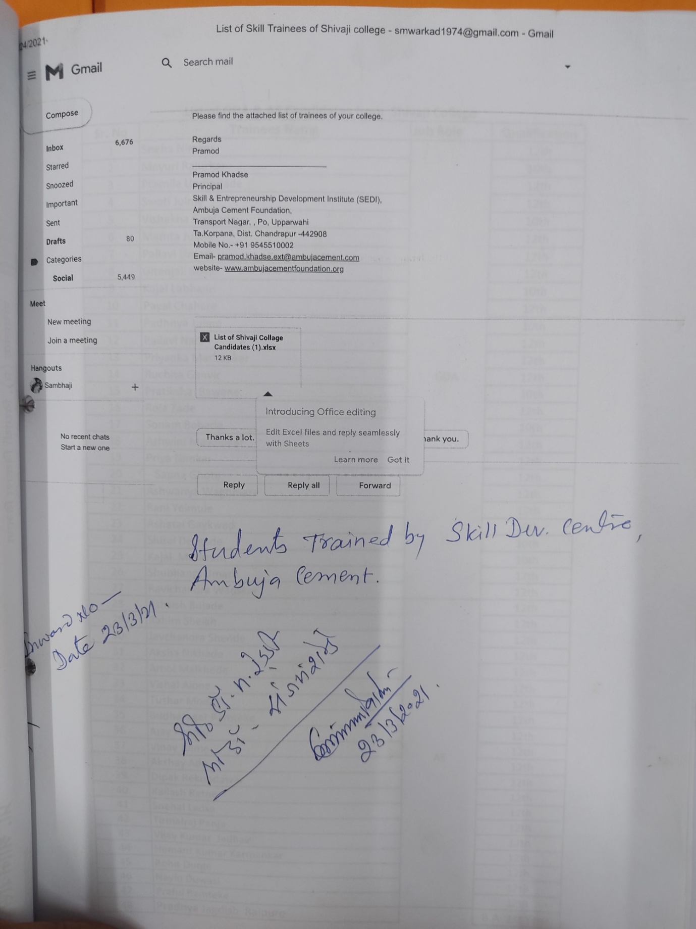

Names of students approved for training at SEDI, Ambuja
